# Instructions

## Compilation

Basic f5 experience should work straight from source code.

We also have CI configured (but not CD – as there’s no test / staging deployment)

## Deployment.

The projects that build a nuget package contain scripts to

* Build the nuget package
* Build and publish to nuget.org

## Important: Updating the Test project

So that we can test the final nuget packages prior to publishing, the SSW.Data.Tests.Integration project does not directly reference the other projects – instead it has manually installed the nuget packages from local disk.

**This means that updates to main projects will not automatically propagate to the test project.**

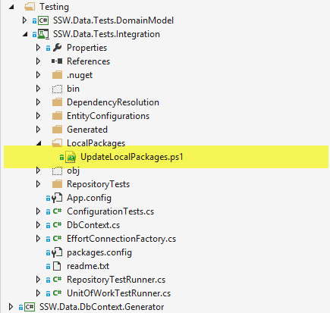

**Figure: run this script to build nugget packages locally and install to test project**

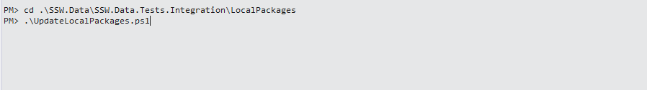

**Figure run script from package manager console.**